**Tutorial No. 6**

# Title: Report on OWASP Top 10

**Roll No.: 16010420075 Tutorial No.: 6**

# Aim: To report on OWASP Top 10

\

**Resources:** virtual box

**Theory**

The Open Web Application Security Project® (OWASP) is a non-profit organization dedicated to enhancing software security. The OWASP Foundation is the source for developers and technologists to safeguard the web through community-led open-source software projects, hundreds of local chapters globally, tens of thousands of members, and leading educational and training conferences.

The OWASP Top 10 is a book/reference document that summarizes the top ten security concerns for web applications. The report is put together by a group of security specialists from across the world, and the data is gathered from a variety of sources before being analyzed.

**__________________________________________________________________________**

**IMPLEMENTATION AND RESULTS:**

The OWASP Top 10 is a standard awareness document for web application security and developers. It reflects widespread agreement on the most serious security threats to web applications.

This document should be adopted by companies, and they should begin the process of ensuring that their online applications minimise these risks. The OWASP Top 10 is probably the most effective initial step toward converting your organization's software development culture to one that creates more secure code.

The top 10 OWASP report looks like this:

**Top 10 Web Application Security Risks**

There are three new categories, four categories with naming and scoping changes, and some consolidation in the Top 10 for 2021.

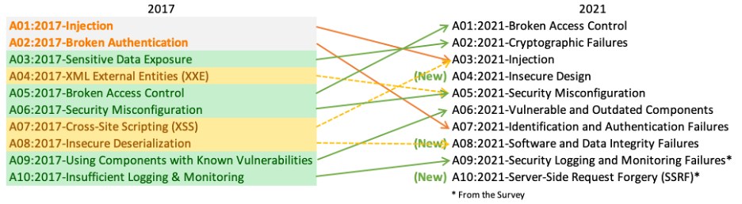

* [**A01:2021-Broken Access Control**](https://owasp.org/Top10/A01_2021-Broken_Access_Control/) moves up from the fifth position; 94% of applications were tested for some form of broken access control. The 34 Common Weakness Enumerations (CWEs) mapped to Broken Access Control had more occurrences in applications than any other category.
* [**A02:2021-Cryptographic Failures**](https://owasp.org/Top10/A02_2021-Cryptographic_Failures/) shifts up one position to #2, previously known as Sensitive Data Exposure, which was broad symptom rather than a root cause. The renewed focus here is on failures related to cryptography which often leads to sensitive data exposure or system compromise.
* [**A03:2021-Injection**](https://owasp.org/Top10/A03_2021-Injection/) slides down to the third position. 94% of the applications were tested for some form of injection, and the 33 CWEs mapped into this category have the second most occurrences in applications. Cross-site Scripting is now part of this category in this edition.
* [**A04:2021-Insecure Design**](https://owasp.org/Top10/A04_2021-Insecure_Design/) is a new category for 2021, with a focus on risks related to design flaws. If we genuinely want to “move left” as an industry, it calls for more use of threat modelling, secure design patterns and principles, and reference architectures.
* [**A05:2021-Security Misconfiguration**](https://owasp.org/Top10/A05_2021-Security_Misconfiguration/) moves up from #6 in the previous edition; 90% of applications were tested for some form of misconfiguration. With more shifts into highly configurable software, it’s not surprising to see this category move up. The former category for XML External Entities (XXE) is now part of this category.
* [**A06:2021-Vulnerable and Outdated Components**](https://owasp.org/Top10/A06_2021-Vulnerable_and_Outdated_Components/) was previously titled Using Components with Known Vulnerabilities and is #2 in the Top 10 community survey, but also had enough data to make the Top 10 via data analysis. This category moves up from #9 in 2017 and is a known issue that we struggle to test and assess risk. It is the only category not to have any Common Vulnerability and Exposures (CVEs) mapped to the included CWEs, so a default exploit and impact weights of 5.0 are factored into their scores.
* [**A07:2021-Identification and Authentication Failures**](https://owasp.org/Top10/A07_2021-Identification_and_Authentication_Failures/) was previously Broken Authentication and is sliding down from the second position, and now includes CWEs that are more related to identification failures. This category is still an integral part of the Top 10, but the increased availability of standardized frameworks seems to be helping.
* [**A08:2021-Software and Data Integrity Failures**](https://owasp.org/Top10/A08_2021-Software_and_Data_Integrity_Failures/) is a new category for 2021, focusing on making assumptions related to software updates, critical data, and CI/CD pipelines without verifying integrity. One of the highest weighted impacts from Common Vulnerability and Exposures/Common Vulnerability Scoring System (CVE/CVSS) data mapped to the 10 CWEs in this category. Insecure Deserialization from 2017 is now a part of this larger category.
* [**A09:2021-Security Logging and Monitoring Failures**](https://owasp.org/Top10/A09_2021-Security_Logging_and_Monitoring_Failures/) was previously Insufficient Logging & Monitoring and is added from the industry survey (#3), moving up from #10 previously. This category is expanded to include more types of failures, is challenging to test for, and isn’t well represented in the CVE/CVSS data. However, failures in this category can directly impact visibility, incident alerting, and forensics.
* [**A10:2021-Server-Side Request Forgery**](https://owasp.org/Top10/A10_2021-Server-Side_Request_Forgery_%28SSRF%29/) is added from the Top 10 community survey (#1). The data shows a relatively low incidence rate with above average testing coverage, along with above-average ratings for Exploit and Impact potential. This category represents the scenario where the security community members are telling us this is important, even though it’s not illustrated in the data at this time.

From the above report, we can see how risks have been listed based on the intensity of attacks. Every now and then unpredictable attacks take place which changes its scale of growth such that it becomes common. OWASP report helps us identify those attacks so that developers can manage their systems accordingly.

**Outcomes:**

**CO-1:** Realize that premise of vulnerability analysis and penetration

testing (VAPT).

**_________________________________________________________________________**

**Conclusion: (Conclusion to be based on the objectives and outcomes achieved)**

A report on OWASP top 10 was prepared.

**Grade: AA / AB / BB / BC / CC / CD /DD**

**Signature of faculty in-charge with date**

**__________________________________________________________________________**

**REFERENCES:**

* [www.owasp.org](http://www.owasp.org)